"""
Q.1) Write a Python function to check whether a string is a pangram or not.
Note : Pangrams are words or sentences containing every letter of the alphabet at least once.
For example : "The quick brown fox jumps over the lazy dog"
"""
s = "The quick brown fox jumps over the lazy dog"
s = s.lower()
alphabet = "abcdefghijklmnopqrstuvwxyz"
for char in alphabet:
if char in s:
is_pangram = True
continue
else:
is_pangram = False
break
if is_pangram:
print("pangram")
else:
("not panagram")

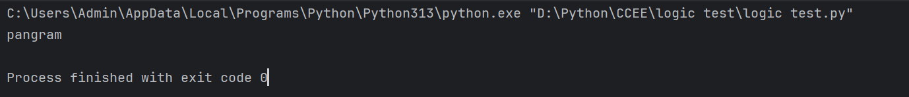

# Q.2) Write a Python program to calculate the sum of the digits in an integer.
num = int(input("Enter an integer: "))
sum_digits = 0
num = abs(num) # handles negative numbers
while num > 0:
digit = num % 10
sum_digits += digit
num //= 10
print("Sum of digits:", sum_digits)

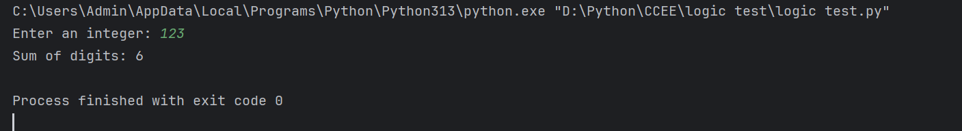
"""Q.3) Write a Python program to sort three integers
without using conditional statements and loops. [ u can use built in functions for this ]"""
a = int(input("Number1: "))
b = int(input("Number2: "))
c = int(input("Number3: "))
sorted_numbers = sorted([a, b, c])
print("Sorted order:", sorted_numbers)

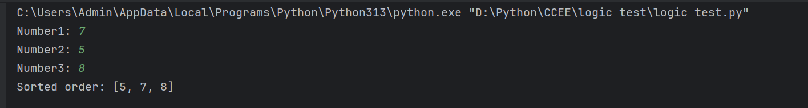

"""
4) Write a Python function to check whether a number is perfect or not.
According to Wikipedia : In number theory, a perfect number is a positive integer that is equal
to the sum of its proper positive divisors, that is, the sum of its positive divisors excluding
the number itself (also known as its aliquot sum). Equivalently, a perfect number is a number that
is half the sum of all of its positive divisors (including itself).
Example : The first perfect number is 6, because 1, 2, and 3 are its proper positive divisors,
and 1 + 2 + 3 = 6. Equivalently, the number 6 is equal to half the sum of all its positive divisors:
( 1 + 2 + 3 + 6 ) / 2 = 6. The next perfect number is 28 = 1 + 2 + 4 + 7 + 14.
This is followed by the perfect numbers 496 and 8128."""
def is_perfect(num):
if num <= 0:
return False
divisor_sum = 0
for i in range(1, num):
if num % i == 0:
divisor_sum += i
return divisor_sum == num
print(is_perfect(6))
print(is_perfect(28))
print(is_perfect(12))

